Comp 421 – Assignment 3

# Question 1

* 20000 tuples
* 600 data pages
* Prefix: 20 bytes
* Full: 30 bytes
* 200 different types
* 50 producers
* Rid has 10 bytes
* Pointer has 6 bytes
* Leaf pages are filled about 70%
* Index page has 4000 Bytes

1. We have possible different values. Then as its uniformly distributed we have 10000 data entries

The number of rids per data entry is

The average length of a data entry is

1. The size of a index entry is. Then the average number of index entry per intermediate page is and the average number of data entry per page is If we have a tree of height 2 then we can cover at most different cases then we need a tree of height 3 as .

Number of leaf pages is and as there is 4 intermediate pages.

# Question 2

## Question 2.1

The first execution plan is the following

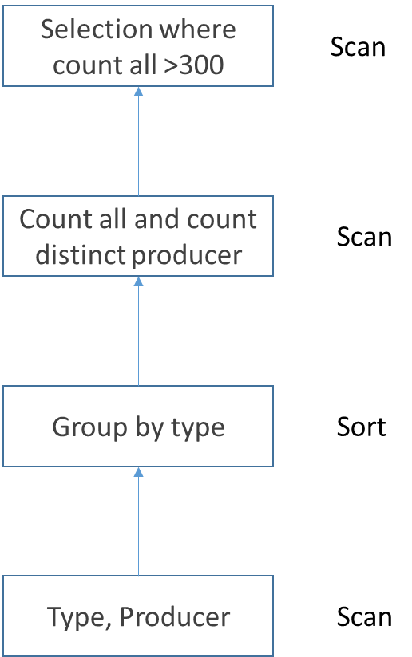

We have 600 pages and as we are searching on arbitrary attribute we have a cost of 600

## Question 2.2

We have 40 000 data pages and 4M entries so there is 100 entries in each pages.

a)

1. As the pid is not sorted we need to go through all possible values. And when we have a corresponding row we can just check the inStock is inferior to Y and return this row or not. Then the cost is 40 000. As we don’t know if the table is sorted using X=200 and Y =10 will be the same cost
2. As we have 20 000 products and 4 million store prices we can suppose we will have in average a match of 200 tuples which means that we will in the worst case get 200 pages. Then the. This will be the same for X=200 and Y=10
3. As inStock is uniformly distributed between 1 and 500 we have on average a result of tuples matching. But as we are using an unclustered index the results are spread across all pages. (Ignoring if Y < 5) the cost will be 40 000 pages + Y leafs page. In the case were Y =10 we have a cost of 40010.
4. With both index we will get Y index pages and data pages to check. Then the cost is So in the case X=200 and Y=10 we will have

b) Changing to a clustered index on pid will not change the cost (Still going to be 2). However changing to a clustered index on inStock will considerably improve the cost. The matching tuples will be clustered into a few adjacent data page so we will access only those few data page.

# Question 3

We have

* 20 000 products on 600 pages
* 4 000 000 store prices on 40 000 pages
* 1000 Stores on 80 pages

1. We will get an output of 4 000 000 tuples as the outer join will get all possible storePrices and as all product are sold somewhere.

# Question 4

**First we are going to select only store where the address contains Montréal before the join.**

**Now we are going to select only the store prices where the sellings prices * inStock < 10 before join.**

**We are going to only select required column before joining.**

**Finally we are going to switch the cross product with a join by switching the order of joins**

